ANNUAL REPORT TO THE CHANCELLOR, 2010-11
Appalachian State University
The Honors College Annual Report 2010-11

THE HONORS COLLEGE
The Honors College was created July 1, 2010
The College head now reports to Provost, as recommended by the National Collegiate Honors Council
guidelines, but is still “Director” not “Dean,” as also recommended by NCHC
The name “Heltzer” was not used for the College, but was attached to a subsidiary program (see
below, HHP for IE)
The Honors College Faculty (21 faculty members list in Appendices) voted on a governance document
(attached below) and elected the membership to the two standing committees:
The Honors College Academic Program Approval Committee
The Honors College Faculty Review Committee Committee

ADMISSIONS

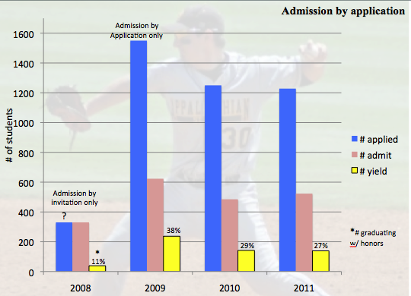
Implemented third round of admissions by application process
Continuing 2011 data: apps=1250+/ accept=527/yield=177; ave
M/V SAT=1340 [number of >1500 SATs at ASU up, ’08= 12; ’09=24;’10=34; ‘11= 36]
Final 2010 data: apps=1250/ a=510/y=140; SAT=1342
Final 2009 data: apps=1550/a=617/y=237; SAT=1307 [1283 in 08]

ENROLLMENT

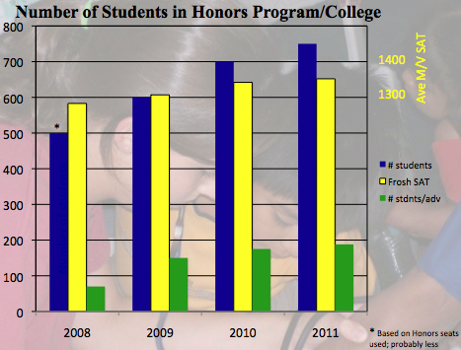
Total number of HC students steady at ~750. Rising seniors last class of “admission by invitation” and uncertain number in class.
While total number of students increased (blue bars, 500 to 750), ave SAT of incoming class rose as well (1283 to 1340).
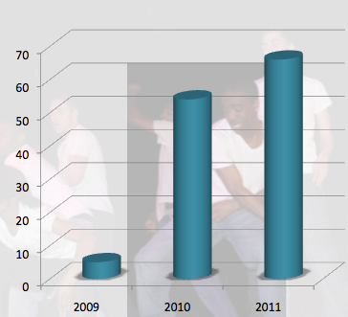
Aggressive internal applicant program (new in 2008) is increasing number of qualified students already at ASU getting opportunity of Honors
Invite freshmen with >3.5 GPA after 1st semester to apply
On track to admit ~80 external transfers and ASU late admits
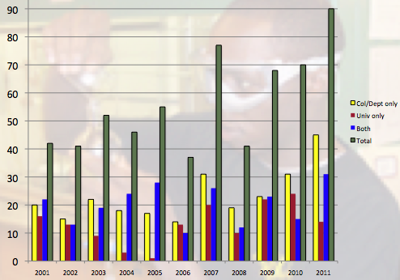
Had two University Honors graduation Honorum Laurus celebratory events; number of students completing theses rising slowly
Dec 2010 + May 2011; Total of 46 graduates with University Honors (red + blue)
Number of Dept Honors theses also increasing (yellow + blue)

Projections: ASU’s undergraduate numbers are ~ 15,000; typically honors is 5-10% of the student body, which would be 750-1500. Honors at APP is at the low end. A 2008 proposal was to expand to ~1200, but this requires doubling the office staff to support the students as required for Honors. Until that is possible, the class size must be limited to current levels.
Comparisons of Honors staff sizes/student numbers:
UNC-Wilmington 4/500; Bowling Green 7/600; College of Charleston 7/700; APP 5/750; U Miss 10/860; Texas Tech 13/1000; Penn State 23/1600

CHANCELLOR’S SCHOLARSHIP

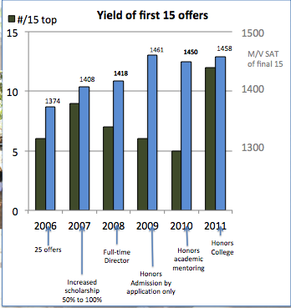
Yield best in last four years: 12 of top 15, last alternate was #19
compared to 5/15 in ’10 and last alternate was #30; 6/15 in ’09, #31 last alt. green bars
Ave M/V SAT stable ~1460 since full scholarship (2007) + change to new interview process in 2009
Still losing students to other scholarships with summer support (e.g., Levine at UNC-C)

ACADEMICS & ADVISING

Offering HON courses continues to be a challenge as chairs decline to reassign faculty to teach
HON course offerings for 2010-11
Fall 2010: nine 1515s, five 2515s, and four 3515s
Spring 2011: no 1515 needed, five 2515s; six 3515s
Note that several of these were offered as cross-listed classes, which seems to be working as a model to increase class size and diversity
Estimate on seats needed per year: with ~800 students (projected growth): HON
1515: 160 (8 sections); HON 2515: 120 seats (6 sections/semester to cover 800 students
fulfilling this once over 6 semesters); HON 3515: same as for 2515.
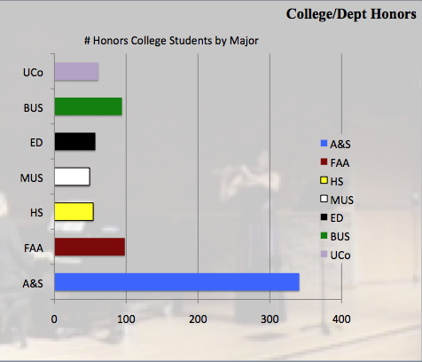
Continued new, required Honors academic mentoring for incoming students (140) and required advising for continuing, undeclared students
Continued voluntary advising for declared majors: this is now putting substantial strain on the Advising staff.
Official advising caseloads were:
LSJ=166; MEL=137; ADM=155; ZU=148; DEW=79. This list (685) is not complete, Banner is missing ~ 62. It also does not represent the large numbers of already-declared majors who come for unofficial advising. See in graph the distribution of declared Honors College students by college.
Also, note that Dr. Wheeler does his advising as an extra service that is not in the scope of his position as Director of PSP (see below), and I should not be advising 166, but until
we get another advisor, I have to share the load with the other two full-time advisors.
Implemented the introduction of a Learning Assistance Program workshop for all incoming HHP students successfully, thanks to C. Duke and other LAP staff.

Pre-law/business advisor:
Since Zack Underwood left, we have replaced this position with a J.D. pre-law/business
advisor, shifting the art/music advising to Dr. Lane, as he will have some moved to
Kent Miller, the new advisor.

Kent Miller will be creating a new model for pre-law advising in Honors and piloting this
opportunity for pre-professional legal studies advising, regardless of major, to the
wider university as well. Celeste Crowe (Director, office of pre-professional health
advising) and Dr. Marion Williams (faculty advisor to the Political Science pre-
professional legal studies concentration) are advisory on this new initiative.

ACADEMIC PARTNERSHIPS

Established Memorandum of Understanding with Southwestern Community College (see
appendix of document). This is the first such MoU for ASU with Honors and a community college, but this initiative is being offered to other CCs, and those without honors programs are being encouraged to create them.
Working on creating a clinical internship experience at ASU’s partner school, the University of
the Free State in Bloemfontein, SA. UFS already has a partnership with the Honors College through the undergraduate, neuroscience journal IMPULSE, hosted at ASU through Honors.

INTERNATIONAL EDUCATION
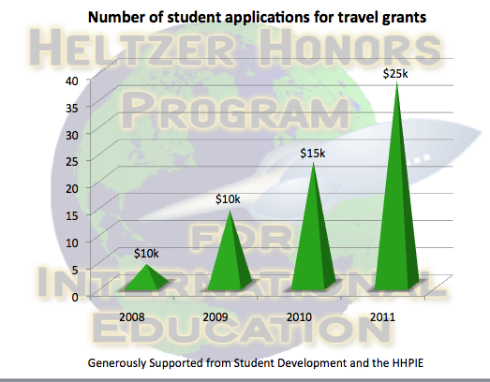
The name “Heltzer” was not carried with the transition to “College,” but
the Heltzer Honors Program for International education was created to acknowledge the annual scholarship support from Mrs. Heltzer and Dr. & Mrs. Mitsch.
Coupled with the generous support of Student Development, the fund has grown, as have the applications for support for international study, from fewer than 10 in 2008 to over 35 in 2010-11.

ADVANCEMENT
Worked with David Taylor in Advancement (also with Don Frezza, Pat Setzer, and Greg Langdon of Alumni giving) on a mailing and telephone solicitation. This yielded 25 donors for this first-ever ask for Honors. Total donations were $3,220 (but $1500 of that was not in response to the mail/phone solicitation).
Stewardship of major donors:
Continued contact with Mrs. Heltzer, nominated her for Honorary degree, conferred in Dec. 2010; Mrs. Heltzer gave another $5000 scholarship gift in December
Continued contact with Dr. Mitsch, who has committed $50,000/5 years to the HHP four IE.
Sent thank you to Hunter family, as usual, for annual gift, but no response for third year.

COMMUNICATION

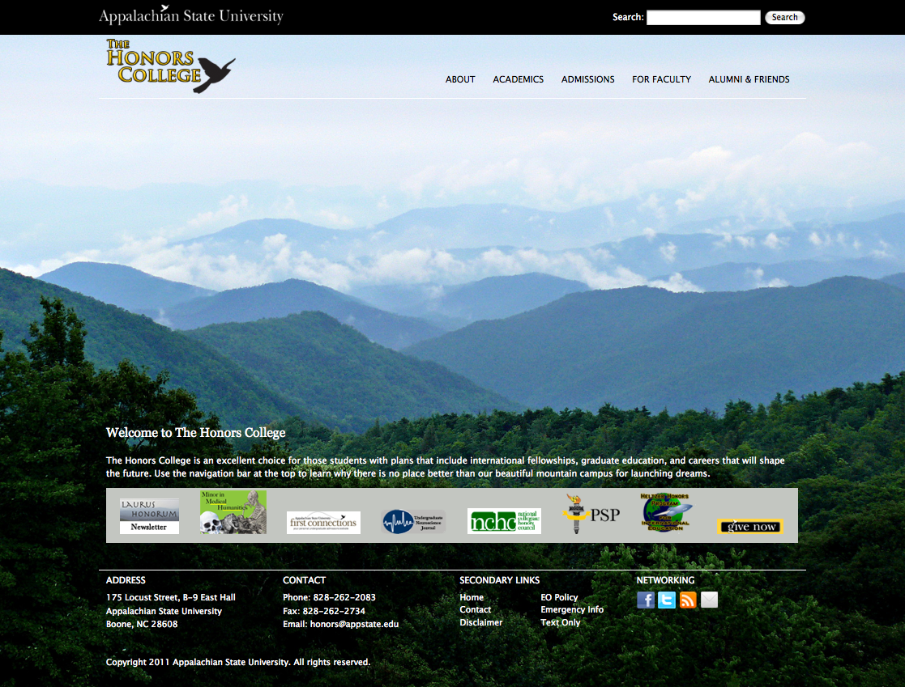
The website was moved to a Drupal format in-house by ZU in the fall, but a redesign by IT was requested in October 2010; it was not delivered until May 2011 as ZU left, so the College has been struggling with having the site look and work as it should. There is

no staff person to spare to support it, though it is intended that the new pre-law advisor, Kent Miller, would take on that task. http:/www.honors.appstate.edu

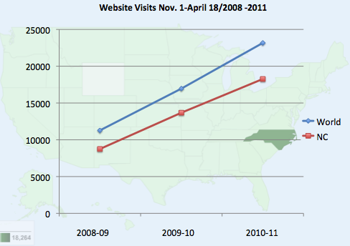
The website is critical to the visibility of the College for everything from recruiting to donor interest. During the last three years the site has seen considerable growth in traffic (shown at right), with web views doubling since fall 2008, from over 10,000 nationally to almost 25,000.

A new initiative in Honors was to create a quarterly newsletter, the Laurus Honorum. This has been done for the first year, with four issues now available online. The issues cover course updates, news about current students, graduates and items about Honors faculty.

The University Communication office is updating an Honors trifold to be used for recruiting and general information mailings/Open House.

ASSESSMENT

The assessment tools created last year continue to be used to collect assessments for the program on the following:
Thesis committee assessment of graduating student
Graduating student self-assessment after defense
Faculty assessment of class group for HON courses

This compiled information for program and learning outcomes is being entered into TracDat and there should be enough after this academic year to proceed with an analysis in June.

Course evaluations continue to be done using recently revamped forms and are useful in determining if courses should be repeated. Students continue generally satisfied with courses. Exceptions will not be pursued further.

DEPARTMENTAL HONORS
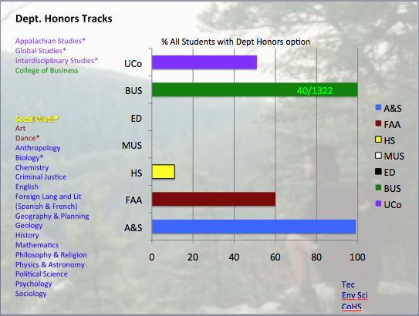
Added departmental honors programs in:
Dance; under construction: TEC and CoHS
There are currently NO opportunities to graduate with honors in two colleges: Music and Education. This affects are large number of Honors College students, but more importantly leaves students not in the Honors College with no way to pursue an honors experience (e.g., individual mentoring, preparation for graduate school, a thesis) and be recognized for their additional effort and academic excellence. This is particularly a disadvantage for non-honors transfer students, who cannot enter the Honors College with >60 s.h.

BUILDING PROJECTS
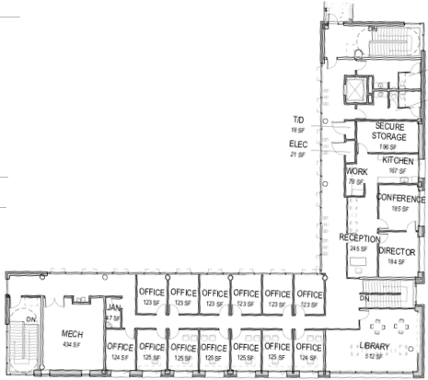
The “new Coffey” residence hall is being built, though no word yet if the Honors population is to move there in fall 2012. Possibly not? This is a major problem.
After much back-and-forthing, it appears that the L-wing building that would house the Honors College is being built as originally planned. The Level 02 office floor is shown at right. No word for sure as to the use of this space, but if it proceeds as intended a year ago, The Honors College would move into the top two floors in spring 2013. The building was designed with some accommodation for the anticipated growth in Honors when the budget allows for the projected increase in staff to support the needed growth
in students (see Enrollment above).

Prestigious Scholarship Program

See attached report after Appendix; webpage (http://www.honors.appstate.edu/psp/)

Respectfully submitted,

Leslie Sargent Jones, Director
The Honors College
31 May 2011

2010-2011 PRESTIGIOUS SCHOLARSHIP PROGRAM (PSP) ANNUAL REPORT
Dr. Dale E. Wheeler, Director
May 27, 2011

Overview: Since 2000, the Appalachian State University Prestigious Scholarship Program (PSP) has
continually supported enrichment activities and has provided opportunities for Appalachian’s most
promising students. This year, the program focused on three major areas, the AIM High
program, APPetite for Life, and support for the submission of competitive scholarship applications.

AIM High: In July 2010, ~225 students were invited to participate in the AIM High program. The application can be found at http://psp.appstate.edu/join-aim-high
The criterion was 30-60 semester hrs and a minimum GPA of 3.75. Around 125 students
completed the online application to participate in the program. Five meetings were held
throughout the year.

APPetite for Life: APPetite for Life is a program that brings faculty and students together for
conversations about preparation for graduate school and scholarship opportunities.
A total of five APPetite for Life Events were held throughout the year. One combined event was
held on Feb 22, 2011 for the remaining Appetite for Life participants.

Prestigious Scholarship Support: Nine external scholarship applications were completed and submitted.
These included a Rhodes Scholarship application, a Mitchell Scholarship application, two Marshall
Scholarship applications, two Fulbright Grant applications, and three Goldwater Scholarship
applications.

AIM High

Rising sophomores with GPAs of 3.75 and higher were invited to join AIM High during the summer 2010. Of the ~225 invitations, ~125 students opted into the group. During these meetings, students were presented with information pertaining to the requirements and opportunities during their time at Appalachian to make their graduate school applications more competitive. Topics included the personal statement, active involvement in research and creative activities, letters of recommendation, resumes, funding opportunities for research projects, and appropriate scholarships.
Five meetings were held through the year.

August 31, Table Rock Room, Introduction to AIM High
October 5, Price Lake Room, Scholarly Activities and Faculty Mentors
November 2, Price Lake Room, Personal Statements and Prestigious Scholarships
February 1, Price Lake Room, Graduate School Round Table Discussion
February 22, Price Lake Room, Resumes, Cover Letters, Letters of Recommendation, and
Appetite for Life Faculty discussions

Following the October, November, and February meetings, follow-up meetings were held the next day at 1:00p and 4:00p for students who were unable to attend the Tuesday evening meeting. Usually, 8-12 students attended the Wednesday meetings.

August 31, 2010 - Introductory Meeting and Banquet - An overview of the program and requirements were presented by Dr. Dale E. Wheeler, Director of the AIM High Program. (About 115 enthusiastic students attended) October 5, 2010 - The presentation began with Dale Wheeler discussing the importance of undergraduate research, effective ways to identify opportunities for undergraduate research, funding opportunities and the responsibilities of students once they have committed to a project. The importance and responsibilities of a faculty mentor were discussed. Guest speakers were Prof. Matk Zrull (psychology) and Prof. Alan Utter (HLES and the Director of the Office of Student Research). Students were given the assignment to identify a potential faculty mentor by the November 2nd meeting. (About 75 students attended)

November 2, 2010 – Feedback was given by students concerning their experiences in identifying a faculty mentor. Questions and discussion followed. Next, Dale Wheeler gave an overview of nine prestigious scholarships. They included the Boren, Fulbright, Goldwater, Hollings NOAA, Marshall, Mitchell, Jack Kent Cooke, Truman, and Udall Scholarships. Information concerning deadlines, references, GPA requirements, the number of applicants and funding rates, year in school eligibility, award amounts and benefits, and majors most likely to apply for each scholarship was given. (About 60 students attended)

February 1, 2011 – Sandra Krause (Graduate School), Jeff McBride (HLES), Kathleen Lynch-Davis (Education), and Joe Cazier (Business) gave short presentations about their respective graduate programs and how to prepare as undergraduates for submission of a competitive graduate school application. Panel members answered questions from students about what to expect in graduate school. Discussion topics included preparation for graduate school applications, expectations for admission, stipends and assistantships, and realistic goals while in graduate school. (About 55 students attended)

February 22, 2011 – Representatives from the ASU Writing Center, Angel Wood from the Career Development Center, Cama Duke (Assoc. Director LAP/Director of LSS), Kaplan Learning Centers, the Office of Student Research, and the Prestigious Scholarships Program have informational tables to provide information to students about their programs, specifically about resumes, cover letters, GRE and funding opportunities. Also, faculty members Marie Hoepfl (Technology), Jamie Russell (Technology), Josh Broman-Fulks (Psychology), Mark Strazicich (Business), and Leslie Jones (Biology / Director Honors College) spoke with students about preparation for graduate and professional schools About 45 students attended)

APPetite for Life

APPetite for Life is a program that brings faculty and students together for conversations about preparation for graduate school and scholarship opportunities. Faculty hosts were also encouraged to bring a graduate student or two from their program area to bring their perspective to the conversations. A total of five APPetite for Life events were held during the fall semester 2010 and ~$1200 was spent on these events.

For those events that were canceled in the fall, faculty and students were invited to a “make-up” APPetite for Life meal on February 22 at the AIM High meeting. (See above for details at the 2/22/11 AIM High meeting summary).

Major | Faculty Host | Location and Date | RSVP By Email psp@appstate.edu
Business | Dr. Joseph Cazier - CIS | Char at 6:30pm on September 30th | CLOSED
Education | Dr. Chrystal Dean - Education  Dr. Shanan Fitts - Elem. Edu | CANCELED | ------------
Health Sciences | Dr. Becki Battista - HLES  Dr. Lanay Mudd - HLES | Hob Knob Cafe at 6:00 pm on October 14th, 2010 | CLOSED
Humanities | Dr. Jennifer Wilson - English  Dr. Tina Groover | Coyote Kitchen at 7:00 pm on October 4th, 2010 | CLOSED
Art/Music/Theatre | Dr. Stephen Hopkins - Music  Dr. Scott Tobias | CANCELED | ------------
Physical Sciences | Dr. Lynn Siefferman - Biology | Casa Rustica at 6:30 pm on September 16, 2010 | CLOSED
Social Sciences | Dr. Adam Newmark - Gov't and Justice | Cha Da Thai at 6:30 pm on October 26, 2010 | CLOSED
Technology | Dr. Jamie Russell - Building Science | CANCELED | ------------

Scholarship Applications

Seven students completed and submitted nine scholarship applications. The PSP staff provided support to ensure that complete and competitive applications were submitted and all requirements were fulfilled by the posted deadlines.

Fall 2010
David Towarnicky Rhodes Scholarship
David Towarnicky Marshall Scholarship
Anna Smith Marshall Scholarship
Anna Smith Mitchell Scholarship
Jasmine Reaves Fulbright Grant
Andrew Spees Fulbright Grant
Jared Harris Goldwater Scholarship
Taylor Sears Goldwater Scholarship
Corianne Rogers Goldwater Scholarship

Assistance for the Fulbright Scholarship applicants included a faculty committee to interview and provided suggestions to the candidates for improvement. Members of the committee included, Shari Galiardi (Director of Service Learning), Nathalie Turner (Assistant Director / Overseas Education Program), Prof. Wayne Vandevender (biology), Ashley Witten (PSP Graduate Assistant), and Prof. Dale Wheeler (Director of the Prestigious Scholarships Program).

Assistance for the Goldwater Scholarship applicants also included a faculty review committee to interview and provided suggestions for improvement. Members of the committee included, Prof. Andy Heckert (geology), Prof. Claudia Cartaya-Marin (chemistry), Prof. Dru Henson (biology), Prof. Chris Thaxton (physics), Dr. Leslie Jones (Director of the Honors College / biology), and Prof. Dale Wheeler (Director of the Prestigious Scholarships Program).

Dr. Leslie Jones provided substantial support and guidance for both David Towarnicky and for Corianne Rogers towards completion of their scholarship applications. The PSP Office is truly grateful for her valuable insight and support of these endeavors.

AIM High Travel Grant Activity

No applications for an AIM High Travel Grant were received this year.

PSP Website

The PSP website was periodically updated to reflect upcoming events and approaching deadlines. A Facebook page was established for the AIM High students and was maintained by Ashley Witten. At the end of the spring semester 2011, the website was reformatted using Druple as the editing software.

Graduate Assistant

This year, I was fortunate enough to have Ashley Witten as a graduate assistant. She worked 20 hours a week throughout the year. She was responsible for organizing and advertising the AIM High meetings. Responsibilities included ordering food through the ASU Food Services Office, reminding AIM High members of upcoming meetings through email, Facebook and Twitter. Ashley was also responsible for organizing the APPetite for Life events described earlier in this report. She also helped with the design of three new PSP brochures. Ashley was a member of a Fulbright interview committee and was responsible for keeping the PSP website updated. Ashley wrote numerous thank you notes to those who wrote letters of recommendations for scholarship applications, assisted with AIM High meetings, or hosted APPetite for Life events.

Honors Advising

In June, October, and March, I advised students entering or currently enrolled in the Honors College program. I met with about 40 students in June, 40 students in October, and about 25 students in March.

Overview

The GA position was better utilized this past year by having increased overlap in office hours and greater oversight on accomplishments.

It is a continuing goal of the PSP Office to increase the number of students who apply for and obtain prestigious scholarships. The AIM High program is now appropriately focused on rising sophomores to advise them in a timely manner on goals for submitting competitive graduate school and prestigious scholarship applications. This summer 2011, invitations will again be sent to rising sophomores with GPAs of 3.75 and higher to apply to join AIM High. Monthly meetings will be held throughout the 2011-2012 AY. APPetite for Life will again have the majority of the events in the fall semester. Faculty from departments not previously represented will be invited to participate. The AIM High travel grants will continue with the goal of having several students attend professional meetings and travel support will be provided to students attending professional that will enhance their chances of obtaining a prestigious scholarship. This year, I have also increased recruiting for prestigious scholarships through discussions with the Honors Council departmental representatives. Also, scholarship informational sessions were held in the fall and spring semesters for the Marshall, Mitchell, Fulbright, Goldwater, Hollings, Udall, and Truman Scholarships.

Dale E. Wheeler
PSP Director
ASU Honors College

