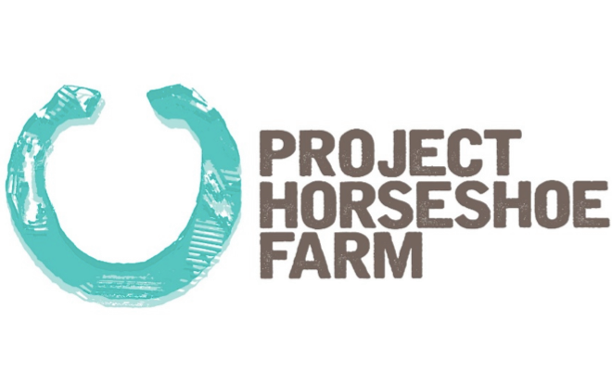 | Project Horseshoe Farm

2019 – 2020 Gap Year Fellowship Application
Deadline: Sunday, February 10th, 2019 at 11:59 PM CST
Email completed application to fellows@projecthsf.org

Applicant Information
Full Name:
 | Last | First | M.I.
Address:
 | Street Address |  | Apartment/Unit #
Permanent Address: | City | State | ZIP Code
 | Street Address |  | Apartment/Unit #
 | City | State | ZIP Code
Phone: |  | E-mail Address:

Date of Birth:

Academic Background Information

1. College or University (currently attending or recently graduated from):

2. Major or Area of Study (and Minor if applicable):

3. Grade Point Average:

4. Your score on any of the following tests: SAT, ACT, GRE, MCAT, GMAT, LSAT, DAT, PCAT:

5. Overview of any graduate work you have done:

Additional Information

1.Please submit the name, title, institution/organization, and contact information (e-mail and phone) for two references whom we can contact.

2. If you are accepted, can you commit to starting on June 17, 2019 and staying until the end of the Fellowship (July 17, 2020)? (If not, please explain).

3. Please indicate whether you are interested in the one-year or two-year Fellowship option:

4. Please indicate whether you are interested in also being considered for our newly established satellite program in Marion, AL or only our primary location in Greensboro, AL.:

5. Have you ever been charged with a crime other than a minor speeding violation or other minor traffic violation? (If yes, please explain) **A full background check will be done on all accepted Fellows**

6. How long have you had your driver’s license?

7. Have you ever received more than 2 traffic tickets in a 12-month period? (if yes, please explain).

8. Have you ever taken a semester or more away from full time school for any reason? (If yes, please explain)

9. How did you find out about the Fellowship? (If applicable, please include names of advisors or contacts)

10. At Project Horseshoe Farm, we believe your word is your bond. Because the selection process is so time intensive, it is critical that selected individuals who accept positions for the Fellowship understand that they are making a commitment to participate in the Fellowship and be prepared to honor their commitments. If you are selected and there is any reason that you might not be able to honor your commitment to participate in the Fellowship, it is critical that you communicate this at the time you decide to accept the position.

I understand the above and agree to honor my commitment if I am offered and accept a position in the Fellowship _______ (Please initial here)

Essay Questions

Please also include:
- A one-page personal statement (please include career goals).

- A statement about why you are applying for the Horseshoe Farm Fellowship and what you hope to bring to the organization if you are accepted (maximum 300 words).

- A description of a period that demonstrated your leadership capacity (can be at school, at work, in a social setting, on a team, in a club or recreational activity, among friends, in the community, etc.). Please describe the circumstances, how you approached the situation, what you did that seemed to be most effective, what you found to be the greatest challenges, and what you learned/what you would do differently. We would be especially interested in any instances where you were able to initiate and/or draw and rally others to a common purpose, activity, or cause (maximum 500 words).

- Please list and briefly describe (no more than 500 words total) the three most significant extracurricular activities you participated in during college (extracurricular organizations, leadership positions, sports teams, work/employment, internships, service work, social organization involvement, etc.)

- Please answer any ONE of the following (no more than 500 words):
  - What is character and why does it matter?
  - What are the two most important virtues and why?
  - Between duty and freedom, which is more important to you and why?
  - What is friendship?
  - What is the goal of raising a child?

Optional Information

- Optional: Please attach a one-page resume
- Optional: Please list any skills you have that would be useful for a rapidly growing community non-profit organization.

